trip1.html

<!DOCTYPE html>

<html lang="en">

<head>

    <meta charset="UTF-8">

    <meta name="viewport" content="width=device-width, initial-scale=1.0">

    <title>Document</title>

    <style>

        body{

            background-color: #BBD6FD;

        }

    </style>

</head>

<body>

    <center><h1>trip images first page</h1></center>

    <p>Lorem ipsum dolor, sit amet consectetur adipisicing elit. Fugiat unde quod odio ut quis iusto harum facere soluta? Aperiam cum placeat quos harum odio magni, facilis unde asperiores illum dicta.</p>

    <img src="images/img1.avif" alt="">

    <img src="images/img2.avif" alt="">

    <img src="images/img3.avif" alt="">

    <img src="images/img4.avif" alt="">

    <img src="images/img5.avif" alt="">

    <img src="images/img6.avif" alt="">

    <img src="images/img7.avif" alt="">

    <img src="images/img8.avif" alt="">

    <img src="images/img9.jpg" alt="">

    <img src="images/img10.avif" alt="">

<hr>

<hr>

<center><a href="trip5.html">back</a> <a href="trip2.html">next</a></center>

</body>

</html>

Trip2.html

<!DOCTYPE html>

<html lang="en">

<head>

    <meta charset="UTF-8">

    <meta name="viewport" content="width=device-width, initial-scale=1.0">

    <title>Document</title>

    <style>

        body{

            background-color: #BBD6FD;

        }

    </style>

</head>

<body>

<center>    <h1>trip images second page</h1></center>

    <p>Lorem ipsum dolor, sit amet consectetur adipisicing elit. Fugiat unde quod odio ut quis iusto harum facere soluta? Aperiam cum placeat quos harum odio magni, facilis unde asperiores illum dicta.</p>

    <img src="images/img1.avif" alt="">

    <img src="images/img2.avif" alt="">

    <img src="images/img3.avif" alt="">

    <img src="images/img4.avif" alt="">

    <img src="images/img5.avif" alt="">

    <img src="images/img6.avif" alt="">

    <img src="images/img7.avif" alt="">

    <img src="images/img8.avif" alt="">

    <img src="images/img9.jpg" alt="">

    <img src="images/img10.avif" alt="">

<hr>

<hr>

<center><a href="trip1.html">back</a> <a href="trip3.html">next</a></center>

</body>

</html>

Trip3.html

<!DOCTYPE html>

<html lang="en">

<head>

    <meta charset="UTF-8">

    <meta name="viewport" content="width=device-width, initial-scale=1.0">

    <title>Document</title>

    <style>

        body{

            background-color: #BBD6FD;

        }

    </style>

</head>

<body>

  <center>  <h1>trip images third page</h1></center>

    <p>Lorem ipsum dolor, sit amet consectetur adipisicing elit. Fugiat unde quod odio ut quis iusto harum facere soluta? Aperiam cum placeat quos harum odio magni, facilis unde asperiores illum dicta.</p>

    <img src="images/img1.avif" alt="">

    <img src="images/img2.avif" alt="">

    <img src="images/img3.avif" alt="">

    <img src="images/img4.avif" alt="">

    <img src="images/img5.avif" alt="">

    <img src="images/img6.avif" alt="">

    <img src="images/img7.avif" alt="">

    <img src="images/img8.avif" alt="">

    <img src="images/img9.jpg" alt="">

    <img src="images/img10.avif" alt="">

<hr>

<hr>

<center><a href="trip2.html">back</a> <a href="trip4.html">next</a></center>

</body>

</html>

trip4.html

<!DOCTYPE html>

<html lang="en">

<head>

    <meta charset="UTF-8">

    <meta name="viewport" content="width=device-width, initial-scale=1.0">

    <title>Document</title>

    <style>

        body{

            background-color: #BBD6FD;

        }

    </style>

</head>

<body>

<center>    <h1>trip images fourth page</h1></center>

    <p>Lorem ipsum dolor, sit amet consectetur adipisicing elit. Fugiat unde quod odio ut quis iusto harum facere soluta? Aperiam cum placeat quos harum odio magni, facilis unde asperiores illum dicta.</p>

    <img src="images/img1.avif" alt="">

    <img src="images/img2.avif" alt="">

    <img src="images/img3.avif" alt="">

    <img src="images/img4.avif" alt="">

    <img src="images/img5.avif" alt="">

    <img src="images/img6.avif" alt="">

    <img src="images/img7.avif" alt="">

    <img src="images/img8.avif" alt="">

    <img src="images/img9.jpg" alt="">

    <img src="images/img10.avif" alt="">

<hr>

<hr>

<center><a href="trip3.html">back</a> <a href="trip5.html">next</a></center>

</body>

</html>

Trip5.html

<!DOCTYPE html>

<html lang="en">

<head>

    <meta charset="UTF-8">

    <meta name="viewport" content="width=device-width, initial-scale=1.0">

    <title>Document</title>

    <style>

        body{

            background-color: #BBD6FD;

        }

    </style>

</head>

<body>

    <center><h1>trip images second page</h1></center>

    <p>Lorem ipsum dolor, sit amet consectetur adipisicing elit. Fugiat unde quod odio ut quis iusto harum facere soluta? Aperiam cum placeat quos harum odio magni, facilis unde asperiores illum dicta.</p>

    <img src="images/img1.avif" alt="">

    <img src="images/img2.avif" alt="">

    <img src="images/img3.avif" alt="">

    <img src="images/img4.avif" alt="">

    <img src="images/img5.avif" alt="">

    <img src="images/img6.avif" alt="">

    <img src="images/img7.avif" alt="">

    <img src="images/img8.avif" alt="">

    <img src="images/img9.jpg" alt="">

    <img src="images/img10.avif" alt="">

<hr>

<hr>

<center><a href="trip4.html">back</a> <a href="trip1.html">next</a></center>

</body>

</html>

Output screens:

Screen1 :

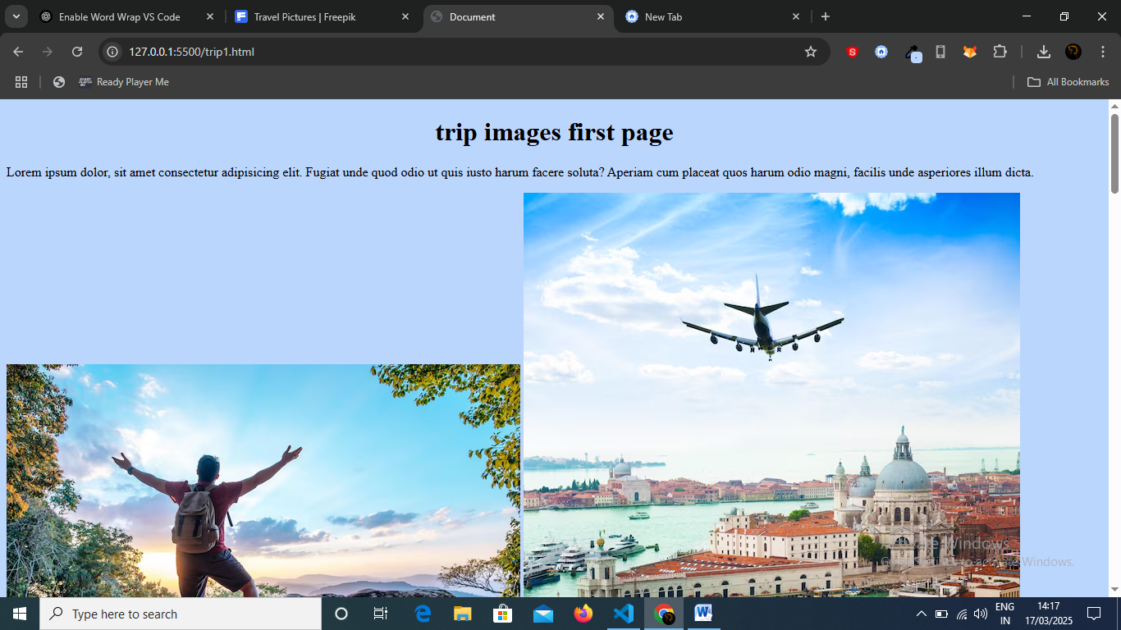

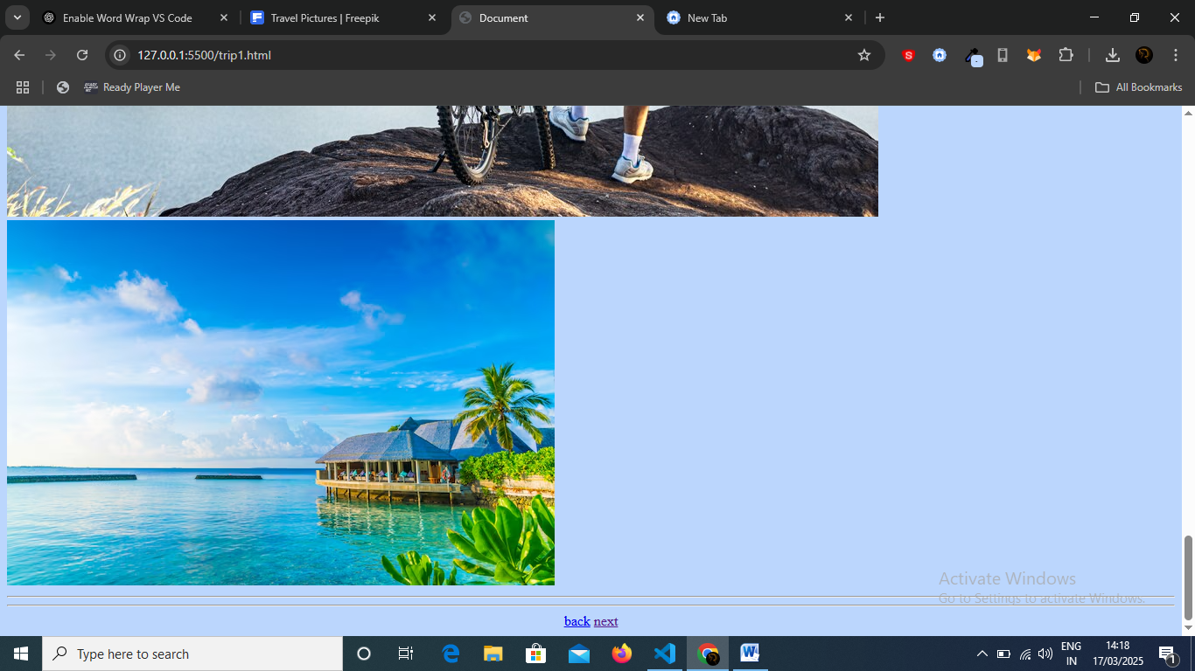

Screen2 :

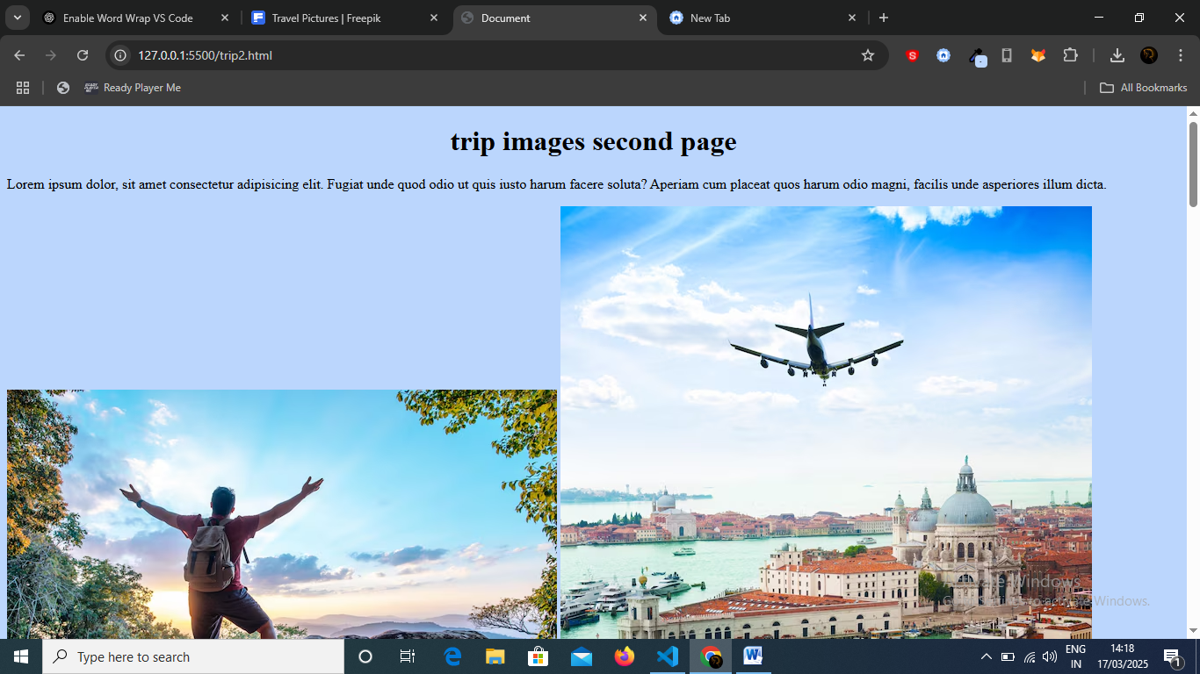

Screen 3:

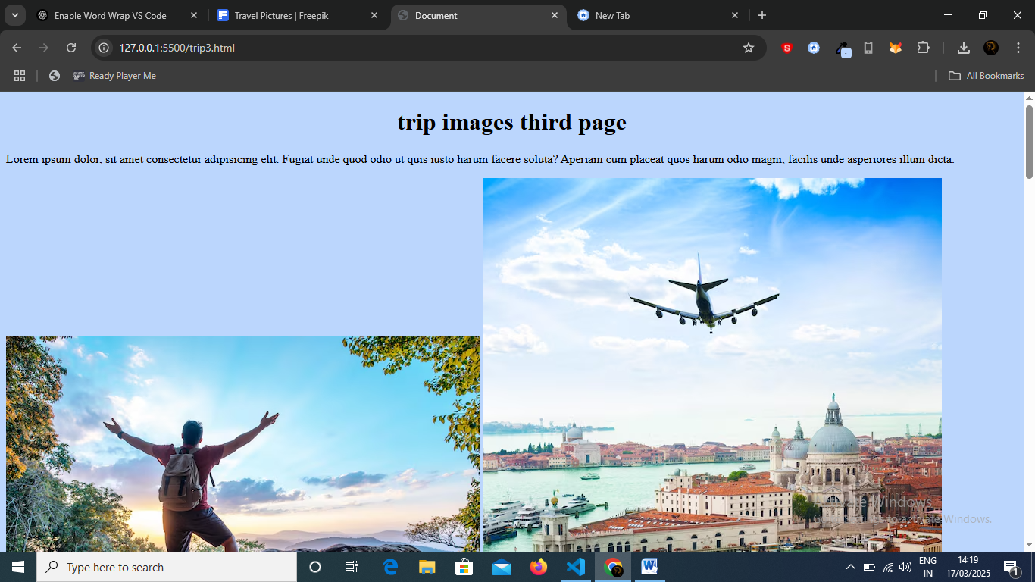

Screen 4:

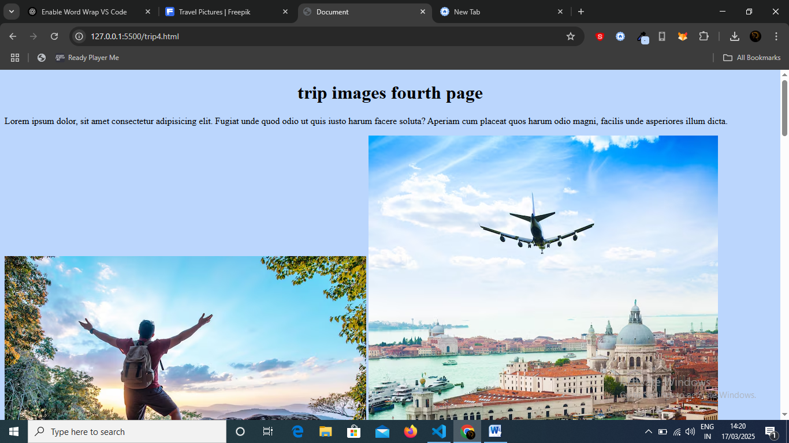

Screen5:

